Mohamed Deraz Nasr
HAAG Photogrammetry Project
Fall 2026
September 25, 2026
Week 4 Report
Colour calibration implementation and validation
Progress this week
- Opened upstream PR 18, Add per-camera ColorChecker calibration command, from the forked mohamed/color-calibration branch and packaged a reproducible synthetic demonstration.
- Added confidence-gated automatic chart detection while retaining reviewed four-corner input as the safe fallback for contact, occlusion, or low-confidence cases.
- Added colour-target provenance so the command supports relative camera alignment now and a defensible absolute target once the physical chart edition is confirmed.
- Implemented specimen-mask-only clipping diagnostics and a conservative 0.5-percentage-point warning threshold; both observed archive mask-name conventions are supported.
- Repeated the method on UF_birds_ivory2: 138 full-resolution images across three usable cameras, with the partly occluded fourth chart explicitly excluded.
- Ran an independent 36-view original-versus-calibrated reconstruction and CPU sparse-Delaunay mesh comparison after full dense MVS was blocked by unavailable CUDA/PACE access.
- Expanded focused coverage to 14 passing colour tests and updated the PR, CLI documentation, evidence reports, weekly database, and handoff notes.
Key results
Metric | Original | Calibrated | Change
UF_Herp_3998 camera 2 Delta E76 | 9.218 | 3.131 | -66.0%
UF_Herp_3998 camera 3 Delta E76 | 3.698 | 1.432 | -61.3%
UF_birds_ivory2 camera 2 Delta E76 | 7.998 | 2.866 | -64.2%
UF_birds_ivory2 camera 3 Delta E76 | 7.380 | 1.614 | -78.1%
Second-specimen registrations | 33 / 36 | 33 / 36 | Unchanged
Sparse-Delaunay mesh vertices | 3,506 | 3,476 | -0.86%
Sparse-Delaunay mesh faces | 6,962 | 6,905 | -0.82%
Mean reprojection error | 0.8510 px | 0.8530 px | +0.0020 px
Interpretation
Colour error fell on both specimens. The unchanged registration counts, sub-1% mesh-size changes, and small aligned surface difference support the narrower claim that calibration preserved coarse reconstruction behaviour. They do not prove dense or anatomical accuracy.
Blockers
- Absolute calibration remains blocked on the physical ColorChecker manufacturer/model and patch-value edition. The software path is ready, but the current validated claim remains relative camera alignment.
- Camera 2 on UF_birds_ivory2 increased foreground clipping from 0.050% to 0.612%, crossing the warning threshold. More specimens are needed before this threshold becomes an acceptance gate.
- The available local COLMAP build requires CUDA for PatchMatch and PACE was unreachable, so the mesh result is sparse-Delaunay topology evidence, not dense-MVS or anatomical accuracy.

Mohamed Deraz Nasr
HAAG Photogrammetry Project
Fall 2026
September 25, 2026
2. Literature review
Preserving colour fidelity in photogrammetry
Barbero-Alvarez et al. study how acquisition, RAW development, colour space, chart calibration, and texture generation affect cultural-heritage photogrammetry. Their central recommendation is to control colour transformations and evaluate known chart patches after processing. This supports treating colour fidelity as a measurable pipeline property rather than relying on visual appearance alone.
Citation: Barbero-Alvarez, M. A., Brenner, S., Sablatnig, R., and Menendez, J. M. (2023). Heritage, 6(8), 5700-5718. https://doi.org/10.3390/heritage6080300
Color correction using root-polynomial regression
Finlayson et al. compare standard 3 by 3 linear colour correction with polynomial alternatives. Linear correction is simple and exposure-independent, while ordinary polynomial models may introduce exposure-dependent hue shifts; root-polynomial terms retain exposure scaling and can improve accuracy. The present pilot deliberately begins with the lower-complexity linear model and leaves higher-order fitting for held-out evaluation.
Citation: Finlayson, G. D., Mackiewicz, M., and Hurlbert, A. (2015). IEEE Transactions on Image Processing, 24(5), 1460-1470. https://doi.org/10.1109/TIP.2015.2405336
Imageomics colour-calibration software
The Imageomics package uses segmented colour cards and per-channel histogram matching to normalize target images to a reference image. Our real-data test confirmed that histogram convergence does not guarantee patch accuracy or natural full-image colour, motivating the corresponding-patch transform implemented this week.
Citation: Imageomics Institute. color-calibration software repository. https://github.com/Imageomics/color-calibration (accessed September 23, 2026).

Mohamed Deraz Nasr
HAAG Photogrammetry Project
Fall 2026
September 25, 2026
3. What I did and how I verified it
PR and demo
Opened PR 18 and documented a sanitized, reproducible command path.
Detection safety
Automatic detection declines uncertain/contact cases; reviewed corners remain available.
Mask compatibility
Supports both <stem>.mask.png and <image-name>.mask.png; 14 focused tests pass.
Independent colour run
Processed 138 usable images; camera 4 was skipped because its chart was occluded.
Clipping gate
Foreground-only metric raised one explicit warning instead of hiding background-dominated clipping.
Geometry regression
Both runs registered 33/36; mesh size changed by under 1% and aligned mean vertex distance was 0.169% of the robust bounding-box diagonal.

Mohamed Deraz Nasr
HAAG Photogrammetry Project
Fall 2026
September 25, 2026
4. Results visualization
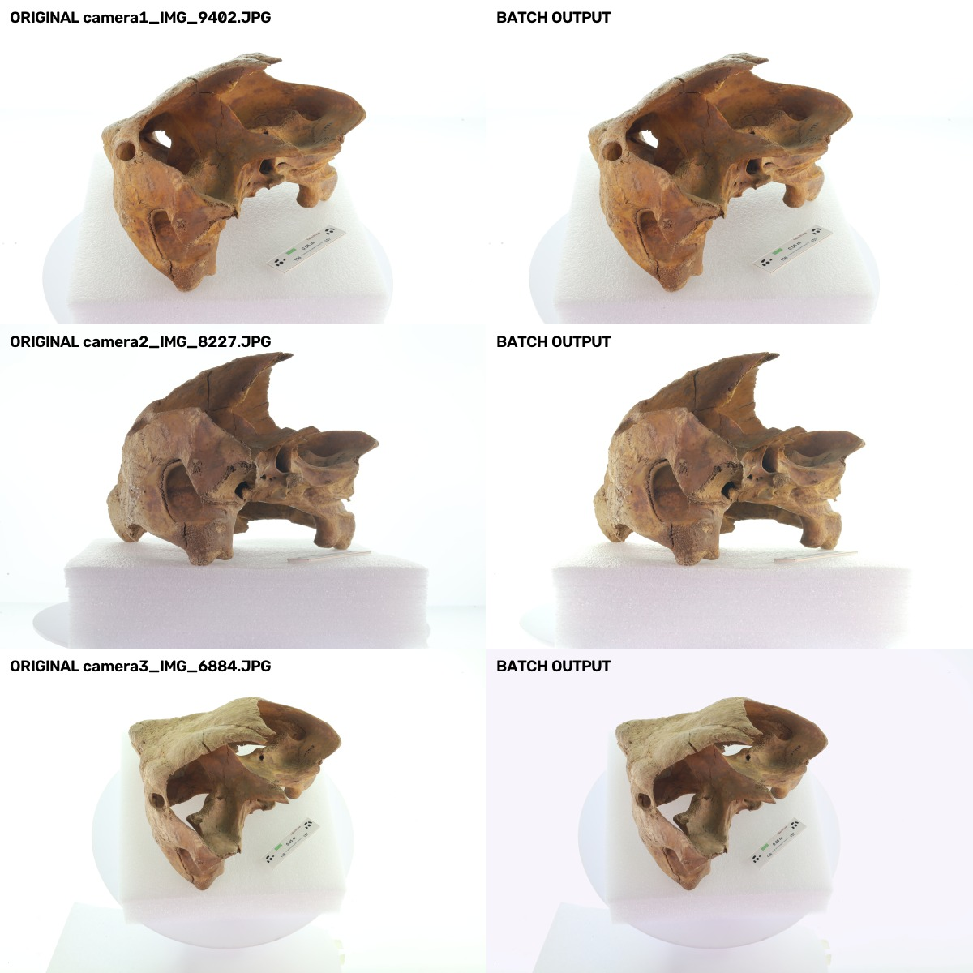
Figure 1. Representative original and calibrated images from the three-camera batch.
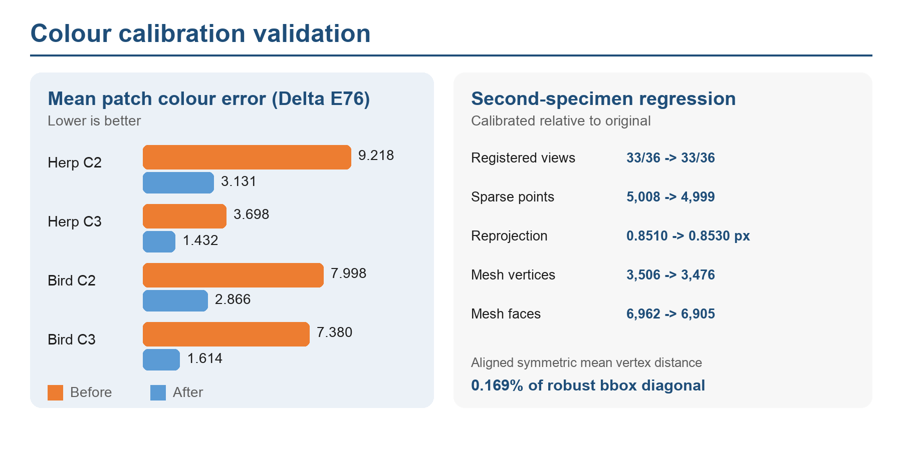
Figure 2. Patch-error reduction across both specimens and the second-specimen sparse-Delaunay regression.

Mohamed Deraz Nasr
HAAG Photogrammetry Project
Fall 2026
September 25, 2026
5. Conclusions and decisions
- Keep the corresponding-patch 3 by 3 linear method as the validated default.
- Use automatic detection only when confidence gates pass; keep reviewed corners as the fallback.
- Treat the camera-2 foreground clipping increase as a warning that requires review, not a hidden failure or a universal rejection threshold.
- Describe geometry as preserved at sparse/coarse topology level; do not claim dense or anatomical validation.
- Keep absolute colour calibration and metric scale as separate, provenance-controlled stages.
Evidence and artifacts
Artifact | Location
Pilot and decision record | documentation/color-calibration-pilot-2026-09-21.md
Implementation | team-repo/src/augenblick/preparation/color.py and augenblick color
Second-specimen evidence | outputs/color-calibration-report-uf-birds-ivory2-2026-09-25.json
Mesh regression | outputs/color-calibration-mesh-regression-uf-birds-ivory2-2026-09-25.json
Mesh comparison utility | scripts/compare_colmap_meshes.py
Pull request | Human-Augment-Analytics/porto-photogrammetry PR 18
Week 5 handoff | documentation/week-5-todo-2026-09-28.md

Mohamed Deraz Nasr
HAAG Photogrammetry Project
Fall 2026
September 25, 2026
Next week
- Obtain the physical chart model and patch-value edition, then rerun the supported absolute-target mode and finalize that part of PR 18.
- Coordinate coded-marker scaling with Ihor's accepted windowed protocol; contribute integration, an independent specimen, or colour/scale interaction testing rather than duplicating his work.
- Run a dense reconstruction or reference-mesh geometry comparison when suitable CUDA/PACE resources and ground truth are available.
- Compare the 3 by 3 model with root-polynomial correction on held-out patches only; require a clear gain without clipping, casts, or exposure instability.
- Request pipeline-owner and Om review, post the PR/demo and evidence in Slack, and turn feedback into named follow-up issues.
- Review Ihor Week 4/5, Om Week 4, and Syed Week 4 for overlaps, reusable artifacts, and coordination decisions.
Team coordination
The Slack database now includes Ihor Week 4 and 5, Om Week 4, and Syed Week 4. Ihor's coded-marker work is already beyond a starting prototype, so the next step is coordination and complementary validation. Meeting 4 also requires matched hardware for wall-clock comparisons and communication before resolving resource conflicts.

